Practical 1: 04/10/2025
To get the version
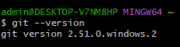
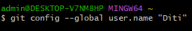
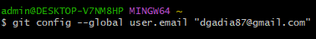
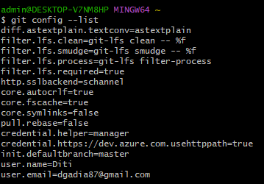
Git lab account banaya
+ > New repository/ project > create blank project.
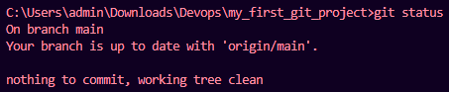
Create a hello.txt file
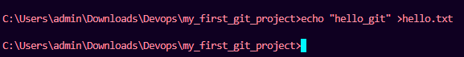
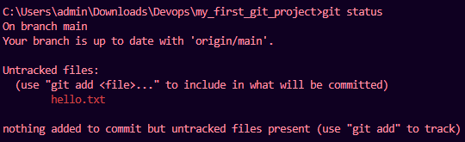
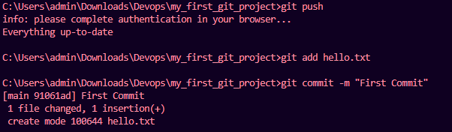
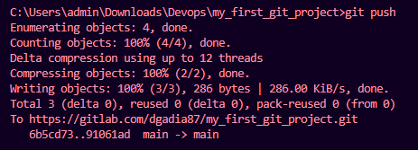
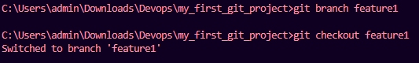
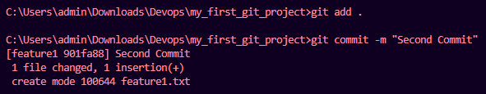
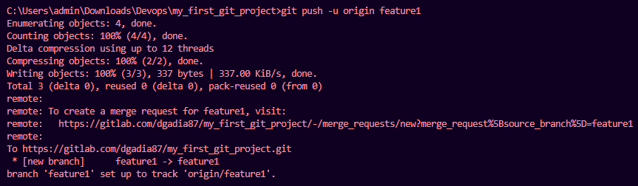
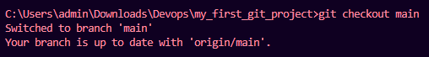
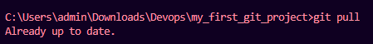
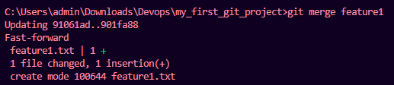
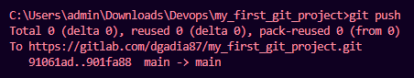
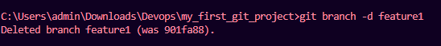
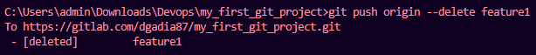
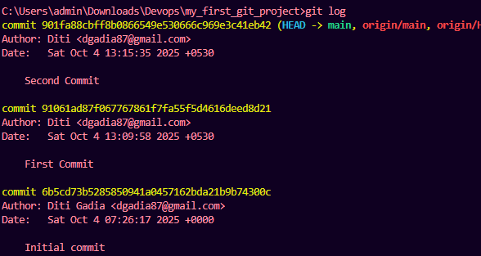

Practical 2: 04/10/25

